Hickory Hollow HOA
Minutes of the Meeting of the Board Open to Community
September 26, 2023, 7:00 PM

Location of Meeting: Zoom
Board members present at Meeting: Beverly Pinckney, Regina Clayton, Delmar Weathersby, Gloria Reid, Mark Robinson

The regular meeting of the Board of Hickory Hollow HOA was called to order at 7:00 PM on September 26, 2023, by Beverly Pinckney.
- Approval of Agenda
The agenda for the meeting was distributed and unanimously approved.
- Review of Previous Minutes
The minutes of the previous meeting were reviewed and unanimously approved.
- Consideration of Open Issues
- Board member attendance called by Beverly Pinckney
- Beverly Pinckney presented to the floor:
The goal of the board is transparency, keeping everyone always involved.
All questions and concerns about the community should be submitted to Beverly Pinckney, President, and Gina Clayton, Vice president for review and resolution.
When using social media platforms make sure to exert professionalism
- Financial report read by treasurer Delmar Weathersby revealed the following:
- Beginning balance ending August 31, 2023 (Alliance Checking: $86, 801.41. Alliance Reserve: $107,628.75 Accounts Receivable: $29, 612.62 this number represents the total Outstanding delinquent accounts).
- Gloria Reid reports on the pond project: The board received two proposals for the pond project. The first proposal involves restoring the stormwater management system by removing all woody stem vegetation within 15 feet of all inflow pipes, outfall structures, and rip rap protection areas. This proposal aims to maintain the structural components of the SWM pond and enhance the overall functioning of the facility (9.750.00). The second proposal includes everything in the first proposal, with the added feature of restoring the community viewshed of the SWM pond, which will enhance its aesthetic appearance (13.500).
- Delmar Weathersby reports that the Homeowners Association (HOA) board of directors has decided to hire a newly established pool company, AMS Aquatic Management System Inc., for the 2024 pool season. The total cost for the 2024 pool season is $11,755. The scheduled maintenance will begin on May 25, 2024, and continue until September 2, 2024. With this decision, the HOA looks forward to having a reliable and successful pool season.
- Gina Clayton details the plans to construct the ADA-compliant section of the community playground. The proposal involves Sartin's and King Swing's materials. The King Swings portion includes an A-frame for standard beams, a Graystone Flex Wall border (per linear foot), ADA Staircase-Vinyl, and a Delivery & Labor Fee totaling $5,445.00. For Sartin's paving portion, grass will be dug out, a stone base of 4-inch compact stone will be added, and asphalt will be laid 2 inches thick. Using a power roller to roll asphalt on walkways (7500). Altogether, the total cost for this proposal comes to $10,795.00.
- Gina Clayton reports, Gina Clayton reports on BC Communities versus New Management Company. The board is in the process of interviewing new management companies. HOA Board of Directors will meet with Knight Property Services by the end of this month. A summary of the meeting's outcomes will be sent to all homeowners. As such, homeowners will be kept up to date on the process and the board's decision.
WHAT IS MISAPPROPRIATION?
Misappropriation of HOA funds refers to the unauthorized use of HOA funds by its board of directors, officers, or employees. This can take various forms, including embezzlement (fraudulent theft of funds by someone in a position of trust or responsibility over those funds), or simply misusing funds for unauthorized expenses. In some cases, misappropriation of HOA funds can also occur due to lack of proper financial controls, poor record-keeping, or a failure to follow the association’s governing documents.
- Beverly Pinckney reports, Annette McAllister, Age Target president, organized a Christmas Toy Drive for the community in December 2022. She funded the entire event herself, without approval or support from the Board of Directors. However, after realizing she had hosted the celebration without the Board's approval, Annette asked for a refund. She was reimbursed $415.00 from the AT budget. In July 2023, Annette also received a refund of $32.50 for pool supplies billed to the AT account without the Board's approval. Unfortunately, Thelma Rose, Treasurer, failed to act regarding the misappropriation. Ultimately, the lack of action from Thelma Rose, Treasurer, was a major factor in the misappropriation of funds.
- 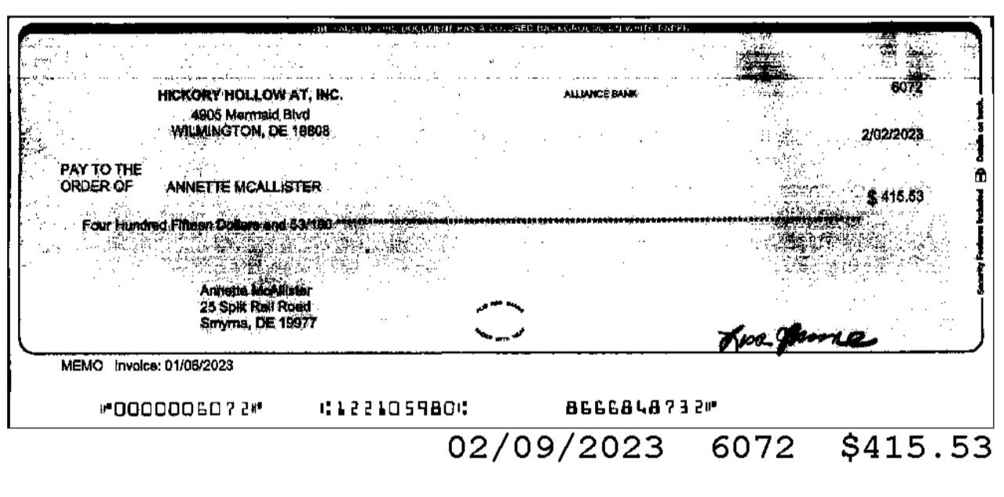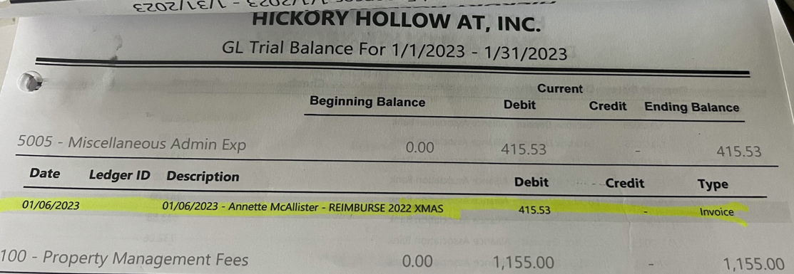
- As a board member, it is important to always prioritize the interests of the association over personal interests. When making decisions for the association, use sound judgment and consider all available information, circumstances, and resources. It is crucial to stay within the boundaries of your authority as defined by law and the association's governing documents. Ensure that residents have the opportunity to comment on association decisions. Perform your duties impartially without any bias towards or against any individual or group of owners or non-owner residents. If you have personal or professional relationships with any company or individual who has or is seeking a business relationship with the association, it is essential to disclose such relationships. Lastly, always speak with one voice and support all duly adopted board decisions, even if you were in the minority regarding actions that may not have obtained unanimous consent. Board members are not allowed to use their positions or decision-making authority to gain individual benefits or seek advantage over other owners or non-owner residents. They must not use association funds for personal benefit. Board members should refrain from attacking their colleagues, staff, or residents. It is also strictly prohibited for them to harass, threaten, or attempt to control or instill fear in any board member, owner, resident, employee, or contractor.
- Abuse of power: During an emergency meeting of the AT Board called by Annette McAllister, a vote was conducted to bring Thelma Rose back to the board. However, Thelma Rose illegally voted for herself to return to the board. Her actions were endorsed by the AT President and Vice President. It is imperative to note that when you resign from an HOA office position, such as treasurer, you are no longer a member of the board. You do not have the right to act on behalf of yourself. To rescind your resignation, you must submit a letter of rescission to the board. The board will then decide whether to accept your resignation or not. Despite this, the AT President allowed Thelma Rose to vote for herself illegally. She then informed the other board members that Thelma Rose would stay on the AT board. Ultimately, this was an illegal and inappropriate action that should not have been allowed.
- Mark Robinson reports: During a board meeting, Mark Robinson was removed from the AT board via an illegal vote. The AT President and Vice President were responsible for this illegal action. Thelma Rose, who had already resigned from the AT board, was allowed to vote for Mark Robinson's removal. Moreover, the AT President, the AT Vice President, and the Treasurer violated Article VIII Officers of the Corporation paragraph 1. Subsequently, the AT Vice President appointed another board member to replace Mark Robinson. This illegal action by the AT President, Vice President, and Treasurer demonstrates a complete disregard for the regulations of the AT Corporation.
- Beverly Pinckney reports that Annette McAllister became boisterous during a board meeting, calling me names and asking me to meet her in my driveway. After that, she came to my home and rang my doorbell in order to continue her unprofessional and threatening behavior. A letter of intimidation was illegally deposited in my mailbox. Consequently, I was left feeling threatened and violated by McAllister's behavior.
- Beverly Pinckney reports on the reasons for the two-year term voting request. Jaimie Titus made the following proposals before resigning as president. An amendment to extend the term for two years. All members of the Main HOA and the AT Board voted in favor of the proposal for the following reasons: two years is a minimum amount of time to really understand what is happening and to get involved in the community. Understanding the association's history is also crucial for board members. Stability and continuity will be provided to the board and community by a longer-term commitment. Having experienced and knowledgeable board members results in better performance and efficiency. With multiple board changes over the years, we may lose touch with processes that will help us be more efficient going forward. Therefore, board members can spend more time working on projects, implementing plans, and building relationships with homeowners. Overall, having a long-term board commitment is beneficial for the board and the community.
Floor open
Homeowner: Could you let me know when the pond issue will be resolved?
Board’s response: There will be immediate action taken regarding the pond issues
Homeowner: Please be aware that the two-year term amendment has two parts to it so make sure that you read both parts
Homeowner: the two terms that you guys are proposing are that vote for new members or is that to keep the present board in place for two years and will the new vote be in-person?
Board’s response: To clarify the two-year proposal with the homeowners, the board sought to explain how and why it was proposed. We will hold our annual meeting in person.
Homeowner: How many estimates are received before you choose a company that you trust and feel as though they are leading you in the right direction because it seems as though the pool and the pond you only got maybe one. I have heard bad things about family pool. I have greenery behind my home and was told several times that they would be pruned. I have been pruning them myself, but I feel that the HOA should fund some of the pruning. The letter that went out between Annette McAllister and Beverly Pinckney I feel that it should be taken up with the police and we should worry about the things that are going on here. I do care about the money and how it spends but to let it get to hear then everyone’s eyes closed.
BCCommunnities manager response: Generally, we provide three estimates to the board of directors
Board response: A new lawncare company will be taking over in January. Board members will meet with them to determine the cost of pruning that area.
Homeowner: I would like to bring your attention to this letter I received up under playground can somebody explain to me it says she never applied for the necessary permits from the town of Smyrna and the playground was found in violation by the town of Smyrna. The original cost of the playground comes over 15000. To bring it up to code it will probably cost our HOA 25376. To remedy. No e got that covered at first glance I thought it was an increase in HOA dues. As long as we are not dealing with anything like that can somebody clarify that?
Board’s response: The playground as done by a committee that was in place before I came on board as the treasurer. Apparently, there was a surveyor questionnaire that went out to homeowners asking about five items they would like to have in the community one of which was a basketball court, walking trail, doggie park, playground etc.it appears that the homeowners’ responses from the survey it was decided to build a kiddie playground. I was not apart from the bidding process unfortunately it’s there now and we must make sure that it’s compliant with the ADA standards or risk fines being enacted. We must add a section for handicapped children as well as a ADA walkway from the parking lot up to the playground.
Homeowner: Will the HOA dues increase because of this?
Board’s response: That question cannot be answered at present we have to look at all the money that is brought in by each homeowner and then all of the expenses that must be paid out,
Meeting adjourned at: 9:00 PM

