Hickory Hollow HOA Newsletter
March/April 2025

Upcoming holidays and celebrations:
March
  - March 1: Many holidays, including Asiatic Fleet Memorial Day, International Open Data Day, National Frozen Food Day, and National Peanut Butter Lover's Day
  - March 3: Casimir Pulaski Day and Read Across America Day
  - March 4: Shrove Tuesday and Mardi Gras
  - March 5: First day of Lent
  - March 6: National Dentist's Day
  - March 14: National Pi Day
  - March 17: St. Patrick’s Day
  - March 20: Spring (vernal equinox)
  - March 29: National Mom and Pop Business Owners Day

April
  - April 1: April Fool's Day, National Sourdough Bread Day, and more
  - April 15: Tax Day
  - April 18: Good Friday
  - April 20: Easter Sunday
  - April 28: Yom HaShoah (Holocaust Remembrance Day)

Community News:

In January 2025 the HH HOA transitioned from BC Communities to IPS as our Property Management Company. IPS sent every household an e-mail or a letter through the USPS with instructions regarding how to set up an account. This will enable us to submit the annual assessment fee. It is imperative every household set up their account through the home.ipsde.com website or through the Vantaca app on your smartphone.

If you are having trouble setting up your new IPS account this is the contact information:
- Name: Ms. Christina Peronti
- Title: IPS Property Manager
- Address: 413 Larch Circle, Newport Delaware 19804
- Email: cperonti@ipsde.com
- Telephone: 302 994-3907

Useful information for maintaining your home as well as understanding how some items work… https://www.myryanhome.com/home-care

RESPECT YOUR NEIGHBORS…
PICK UP your Pooch’s POO

The Smyrna Town code states:
Sec. 14-8. - Accumulation and removal of animal fecal matter (c) Any person in possession of any animal shall immediately remove, in a sanitary manner in an airtight bag or other closed container, any fecal matter deposited by such animal upon any street, sidewalk, park, or upon any other public property, or upon any private property not owned by the person in possession.

The Town of Smyrna, after the third reading of the amended ordinance and unanimous vote by the Town Council on February 3, 2025, has finalized the following code change:

There has been an important change to the Town Code regarding rental properties and may have an impact on certain properties within Hickory Hollow.

The following is the Hickory Hollow Declaration of Private Covenants, Condition, and Restrictions:
Section 2.22 Lease Agreements
All lease agreements for any Lot or Structure must be in writing and submitted to the Board of Directors of the Association for approval. The minimum term of all lease agreements is one year. All lease agreements are subject to this Amended Declaration and must state so clearly. Current copies of any lease must be supplied to the Association. Record Owners who do not reside on their Lot must provide their current addresses and telephone numbers to the Association.
The amended Smyrna town code regarding rentals is as follows:
Amend Chapter 18 (Buildings and Building Regulations), Article XI (Rental
Properties), by making insertions as shown by underline and deletions as shown by strike through, as follows:
Sec. 18-402. Rental license required; exceptions; application and fee.
(a) No dwelling unit may be leased, subleased, or occupied by any person other than the owner until a rental license has been issued by the town.
(b) Exceptions.
(1) No rental license shall be required where the owner occupies the dwelling unit;
(2) No fee shall be charged if the occupant provides written verification that they are directly related to the owner.
(c) Application. Application for a rental license shall be on forms provided by the town and signed by at least one co-owner of the subject property. Such forms shall require, among other information:
(1) The name, address and telephone number of each owner;
(2) The address of the unit(s);
(3) The maximum occupancy of each unit which shall not exceed the maximum allowed by town ordinance;
(4) The name, address, and telephone number of the "caretaker" and "alternate caretaker" as required under section 18-406.
(5) Certification that the owner will provide the tenant(s)/occupant(s) with written notice of the conditions of the occupancy agreement required by section 18-404.
(d) Fee. The annual fee for a rental license shall be as set forth in the fee schedule per unit per calendar year, payable in advance at time of application. Rental license fees are payable by the first day of each calendar year. Licenses applied for and paid for in December of any year shall be issued for the following calendar year.

Sec. 18-403. Rental certificate of occupancy; inspections; exceptions; fee.
(a) Rental certificate of occupancy required before re-occupancy. No rental unit shall be occupied after a vacancy by any person other than the owner or persons related directly to the owner unless a rental certificate of occupancy has been issued by the town as herein provided.
(b) Inspection; rental certificate of occupancy. No rental certificate of occupancy shall be issued until an inspection shall have been conducted by the town to ensure insure that the dwelling unit is in substantial compliance with the building, plumbing, housing, electrical, fire, and property maintenance codes of the town. After notification of vacancy by the owner, the town will conduct the inspection within five working days. A rental unit shall be deemed to be not in substantial compliance if:
(1) There are one or more violations which pose a serious and substantial threat to the health, safety or welfare of the occupants; or
(2) There is an extensive number of minor violations which, cumulatively, pose a
significant threat to the health, safety, welfare or morale of the occupants.

It is the intent of this article, and the code enforcement official shall be guided accordingly, that the greater the cumulative number of violations observed in a rental unit, the less serious any of them must be to result in a determination that a unit is not in substantial compliance; and conversely, the more serious the violations, the fewer there need be to result in a determination that a rental unit is not in substantial compliance.
(c) Exceptions. No rental certificate of occupancy and no inspection shall be required for any of the following:
(1) Any rental unit occupied by the owner or by persons directly related to the owner;
(2) Any rental unit for which a certificate of occupancy has been issued within the past 12 months following construction or substantial reconstruction of such rental unit; Provided however, anything in this article to the contrary notwithstanding, where any dwelling unit otherwise excepted from the requirement of a rental certificate of occupancy and inspection is determined to be in significant violation of any town building, housing, electrical, plumbing, fire or property maintenance code, such dwelling unit shall not thereafter be reoccupied after the first vacancy following such determination until a rental certificate of occupancy shall be issued following an inspection as provided herein. "Significant violation" for purposes hereof shall mean violations which because of their seriousness or because of their extensive number, in the aggregate, pose a significant threat to the health, safety, welfare or morale of the occupants.


Town of Smyrna Yard Waste Program
Begins March 10, 2025
Ends December 11, 2025

If there are any questions, please call the Public Works Dept.
302-652-9288

Another Smyrna School District Referendum
https://www.wdel.com/news/smyrna-school-district-schedules-operating-referendum/article_05ac82e2-dcca-11ef-923b-3f125ec293a0.html

Smyrna School District schedules operating referendum
- WDEL News Published Jan 27, 2025 at 12:00 pm

The Smyrna School District has set an operating referendum for March 15th.

The district is hoping to raise $5.4 million for hiring and retention of teachers and staff, school safety, and certain expenses for extra-curricular activities, clubs and sports. Also, the Smyrna School District hopes to make more investments into technology.

Last year, voters rejected an operating-and-capital referendum but later approved a capital referendum for a new intermediate school when the operating portion was taken out.

Community meetings to explain the referendum, the property tax impact, and to answer questions will take place February 12th at the Central Office at 6:00 p.m. and March 11th at Smyrna Middle School at 7:00 p.m.

If approved, taxes in New Castle County would increase by 39.33 cents per $100 of assessed property value (based on late 1980’s property values – new home assessments start in 2025), based on the current assessed rate. Kent County property owners would pay an additional 9.24 cents per $100 assessed property value. (potentially a $373 increase/year based on a $400,000 assessed home value)

According to the Smyrna School District, if the referendum is not approved "the district will face budget shortfalls which could result in cuts to programs, staffing issues, and other resources that directly impact students and staff."

A meeting to discuss the referendum is scheduled for:
March 11, 2025 at 7PM at Smyrna Middle School
(700 Duck Creek Parkway, Smyrna)

The future of our children and grandchildren will be decided by asking questions, making an informed decision, and voting on
March 15, 2025, 7AM until 8PM
at the following locations: Smyrna Elementary School, Clayton Intermediate School, Kenton Ruritan Club, Smyrna Middle School, and Sunnyside Elementary School

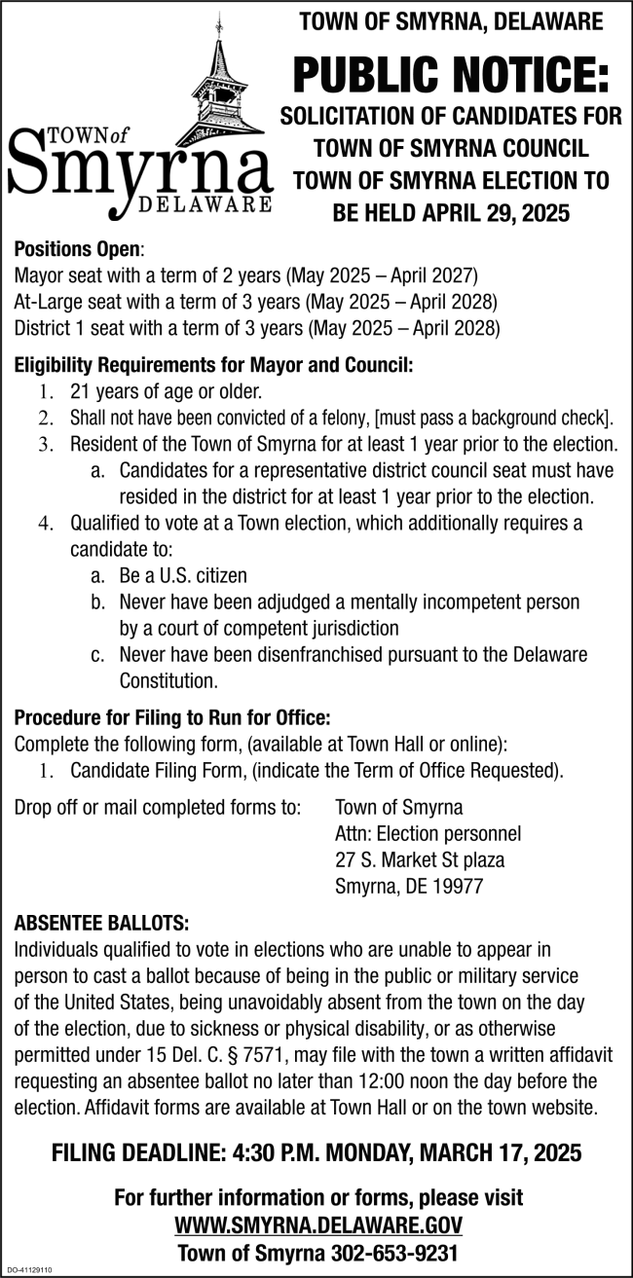

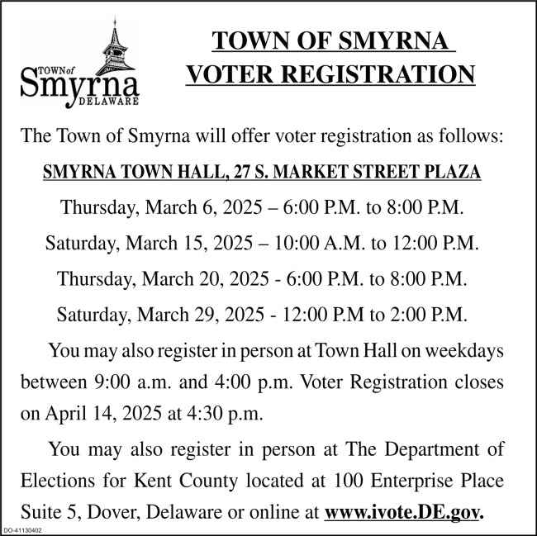

Wedding Bells Word Search

Best Man | Garter | Rehearsal
BOUQUET | Gifts | Rice
Bridal train | Groom | Rings
Candles | Guests | Shower
Ceremony | Honeymoon | Toast
Chapel | Kiss | Usher
Church | License | Veil
Couple | Limousine | Vows
Elopement | Maid of honor | Wedding
Family | Marriage
Flowers | reception

